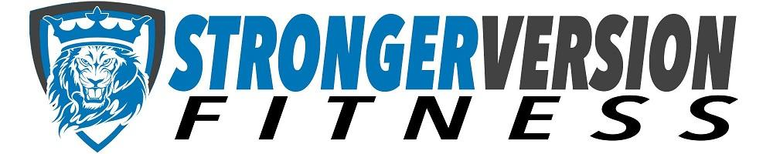

FITNESS CLASSES
July & August 2018

Monday:
8:30am-9:15am Pound-Amanda
Tuesday:
9:00am-9:45am Core de Force-Julie
7:30pm-8:15pm Zumba-Anne & Mandy-rotating
**no class July 3, 17&24
Wednesday:
5:30am-6:15am Zumba-Lori Jo
**no class July 4&11
Thursday:
5:30am-6:00am Total Body Steppin’ Up-Jen
9:00am-9:45am Core de Force-Julie
12:15pm-12:45pm Strength & Stretch-Anne
**no class July 5&26

Friday:
5:30am-6:15am Zumba-Mandy

See class descriptions on back

FITNESS CLASSES
July & August 2018

Monday:
8:30am-9:15am Pound-Amanda
Tuesday:
9:00am-9:45am Core de Force-Julie
7:30pm-8:15pm Zumba-Anne & Mandy-rotating
**no class July 3, 17&24
Wednesday:
5:30am-6:15am Zumba-Lori Jo
**no class July 4&11

Thursday:
5:30am-6:00am Total Body Steppin’ Up-Jen
9:00am-9:45am Core de Force-Julie
12:15pm-12:45pm Strength & Stretch-Anne
**no class July 5&26

Friday:
5:30am-6:15am Zumba-Mandy

See class descriptions on back

CLASS DESCRIPTIONS:

Pound®: Full-body workout that combines cardio, conditioning, and strength training with yoga and pilates-inspired movements while drumming to a wide array of music

Zumba®: Fat-blasting workout using music inspired by countries around the globe. Join the party; let the music move you to a healthier mind & body. There are no wrong moves in Zumba®, and you will leave with a smile on your face.

Total Body Steppin’ Up: Full-body workout using steppers for extra lower body workout. This isn’t your normal step class; as upper body toning is also included. Blast the fat as you step your way to a healthier you.

Core De Force: MMA-inspired full body workout that will help chisel your core and make you leave feeling on top of the world.

Strength & Stretch: Low impact full body workout using bodyweight exercises to build strength, and stretching for flexibility in a relaxed atmosphere.

CLASS DESCRIPTIONS:

Pound®: Full-body workout that combines cardio, conditioning, and strength training with yoga and pilates-inspired movements while drumming to a wide array of music

Zumba®: Fat-blasting workout using music inspired by countries around the globe. Join the party; let the music move you to a healthier mind & body. There are no wrong moves in Zumba®, and you will leave with a smile on your face.

Total Body Steppin’ Up: Full-body workout using steppers for extra lower body workout. This isn’t your normal step class; as upper body toning is also included. Blast the fat as you step your way to a healthier you.

Core De Force: MMA-inspired full body workout that will help chisel your core and make you leave feeling on top of the world.

Strength & Stretch: Low impact full body workout using bodyweight exercises to build strength, and stretching for flexibility in a relaxed atmosphere.

